Component creation 1

# Generate the Component :

You can use Angular CLI to generate a component. Open your terminal and run the following command:

**ng generate component component-name**



or the shorthand:

**ng g c component-name**

This command will create four files:

* **component-name.component.ts**: The TypeScript file for the component's logic.
* **component-name.component.html**: The HTML file for the component's template.
* **component-name.component.css** (or .scss): The CSS file for styling the component.
* **component-name.component.spec.ts**: The test file for the component.

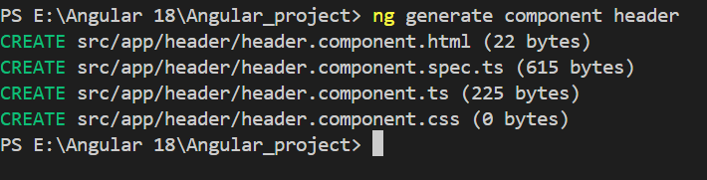

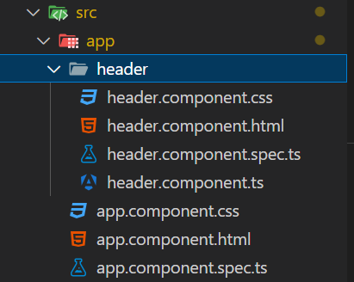

## Example Work :

Creating three components

Header

* ng g c Header

Body

* ng g c Body

Footer

* ng g c Footer

Add html , css code in all created components for the page header , footer and body

**Header>header.components.html**

<header>

    <nav>

        <div class="title">Book Vaccine</div>

        <ul>

            <li><a href="#">Home</a></li>

            <li><a href="#">Contact</a></li>

            <li><a href="#">About</a></li>

            <li><a href="#">Service</a></li>

        </ul>

    </nav>

</header>

**Header > header.components.css**

header {

    background-color: rgb(0, 107, 213);

    padding: 10px 0;

}

nav {

    display: flex;

    justify-content: space-between;

    align-items: center;

    padding: 0 20px;

}

.title {

    color: white;

    font-size: 24px;

    font-family: Arial, sans-serif;

}

nav ul {

    list-style: none;

    display: flex;

    margin: 0;

    padding: 0;

}

nav ul li {

    margin: 0 15px;

}

nav ul li a {

    color: white;

    text-decoration: none;

    font-size: 18px;

    font-family: Arial, sans-serif;

}

nav ul li a:hover {

    color: #ff6347;

}

**Body : body.component.html**

<div class="container">

    <h1>Welcome to the Vaccination Center</h1>

    <div class="content">

        <div class="text">

            <p>We are committed to providing safe and effective vaccines to protect our community.</p>

            <p>Our center is open from 9 AM to 5 PM, Monday to Friday.</p>

            <p>Please bring your ID and vaccination card when you visit.</p>

        </div>

        <div class="image">

            <img src={{bodyImage}} alt="Vaccination Center" class="center-image">

        </div>

    </div>

</div>

**Body > body.component.css**

.container {

    text-align: center;

    padding: 20px;

}

.content {

    display: flex;

    justify-content: space-between;

    align-items: center;

}

.text {

    flex: 1;

    padding-right: 20px;

}

.image {

    flex: 1;

}

.center-image {

    width: 100%;

    height: auto;

}

h1 {

    font-size: 2.5em;

    color: #333;

    margin-bottom: 20px;

}

p {

    font-size: 1.2em;

    color: #666;

    line-height: 1.5;

}

img {

    border-radius: 10px;

    box-shadow: 0 4px 8px rgba(0, 0, 0, 0.1);

}

**Footer > footer.component.html**

<!DOCTYPE html>

<html>

<head>

    <meta charset="utf-8">

    <meta name="viewport" content="width=device-width, initial-scale=1.0">

    <title>Untitled</title>

    <link rel="stylesheet" href="https://cdnjs.cloudflare.com/ajax/libs/twitter-bootstrap/4.1.3/css/bootstrap.min.css">

    <link rel="stylesheet" href="https://cdnjs.cloudflare.com/ajax/libs/ionicons/2.0.1/css/ionicons.min.css">

</head>

<body>

    <div class="footer-basic">

        <footer>

            <div class="social"><a href="#"><i class="icon ion-social-instagram"></i></a><a href="#"><i class="icon ion-social-snapchat"></i></a><a href="#"><i class="icon ion-social-twitter"></i></a><a href="#"><i class="icon ion-social-facebook"></i></a></div>

            <ul class="list-inline">

                <li class="list-inline-item"><a href="#">Home</a></li>

                <li class="list-inline-item"><a href="/service">Services</a></li>

                <li class="list-inline-item"><a href="/about">About</a></li>

                <li class="list-inline-item"><a href="/contact">Contact</a></li>

                <li class="list-inline-item"><a href="#">Privacy Policy</a></li>

            </ul>

            <p class="copyright">V-card © 2018</p>

        </footer>

    </div>

    <script src="https://cdnjs.cloudflare.com/ajax/libs/jquery/3.2.1/jquery.min.js"></script>

    <script src="https://cdnjs.cloudflare.com/ajax/libs/twitter-bootstrap/4.1.3/js/bootstrap.bundle.min.js"></script>

</body>

</html>

**Footer > footer.component.css**

**.footer-basic {**

padding:40px 0;

    background-color:#e0e4e4;

    color:#4b4c4d;

  }

  .footer-basic ul {

    padding:0;

    list-style:none;

    text-align:center;

    font-size:18px;

    line-height:1.6;

    margin-bottom:0;

  }

  .footer-basic li {

    padding:0 10px;

  }

  .footer-basic ul a {

    color:inherit;

    text-decoration:none;

    opacity:0.8;

  }

  .footer-basic ul a:hover {

    opacity:1;

  }

  .footer-basic .social {

    text-align:center;

    padding-bottom:25px;

  }

  .footer-basic .social > a {

    font-size:24px;

    width:40px;

    height:40px;

    line-height:40px;

    display:inline-block;

    text-align:center;

    border-radius:50%;

    border:1px solid #ccc;

    margin:0 8px;

    color:inherit;

    opacity:0.75;

  }

  .footer-basic .social > a:hover {

    opacity:0.9;

  }

  .footer-basic .copyright {

    margin-top:15px;

    text-align:center;

    font-size:13px;

    color:#aaa;

    margin-bottom:0;

  }

Call the components directly to the **app.component.html** page

<app-header></app-header>

<app-body></app-body>

<app-footer></app-footer>

To do this first you should import the components at the **app.components.ts** page components **import[]** section

  imports: [HeaderComponent,BodyComponent,FooterComponent],

**app.component.ts**

import { Component } from '@angular/core';

import { RouterOutlet } from '@angular/router';

import { HeaderComponent } from './header/header.component';

import { BodyComponent } from './body/body.component';

import { FooterComponent } from './footer/footer.component';

@Component({

  selector: 'app-root',

  imports: [HeaderComponent,BodyComponent,FooterComponent],

  templateUrl: './app.component.html',

  styleUrl: './app.component.css'

})

export class AppComponent {

  title='Angular_project';

}

The **OutPut** is :

